**Azure Cognitive Services AI Integration Workflow**

**Step 1 - Create a new LUIS app in the LUIS portal**

**Sign into LUIS portal**

A new user to LUIS needs to follow this procedure:

1. Sign in to [LUIS portal (preview)](https://preview.luis.ai/), select your country and agree to the terms of use. If you see **My Apps** instead, a LUIS resource already exists and you should skip ahead to create an app.
2. Select **Create Azure resource** then select **Create an authoring resource to migrate your apps to.**

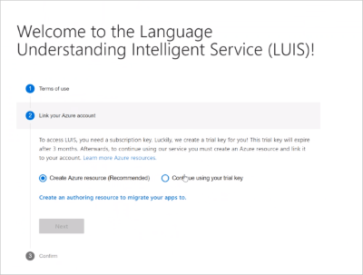

1. Fill in the details for the resource.

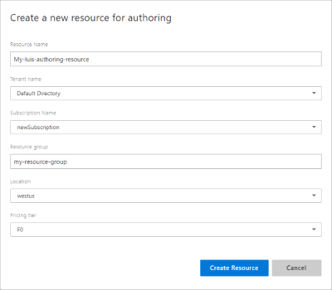

When **creating a new authoring resource**, provide the following information:

* + **Resource name** - a custom name you choose, used as part of the URL for your authoring and prediction endpoint queries.
  + **Tenant** - the tenant your Azure subscription is associated with.
  + **Subscription name** - the subscription that will be billed for the resource.
  + **Resource group** - a custom resource group name you choose or create. Resource groups allow you to group Azure resources for access and management.
  + **Location** - the location choice is based on the **resource group** selection.
  + **Pricing tier** - the pricing tier determines the maximum transaction per second and month.

1. A summary of the resource to be created is displayed. Select **Next**.

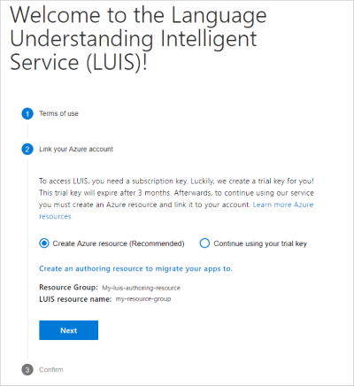

1. Confirm by selecting **Continue**.

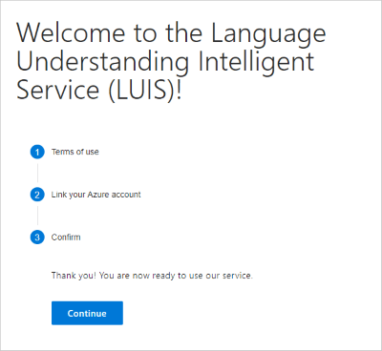

**Step 2 – Create new app in LUIS**

1. On **My Apps** page, select your subscription, and authoring resource then **+ Create**.

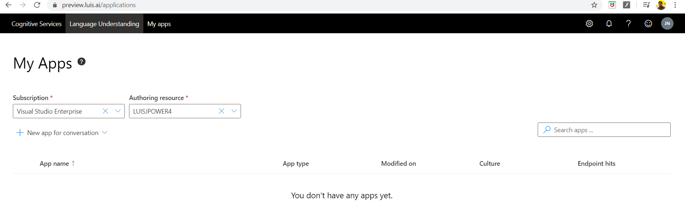

1. Create new app for conversation

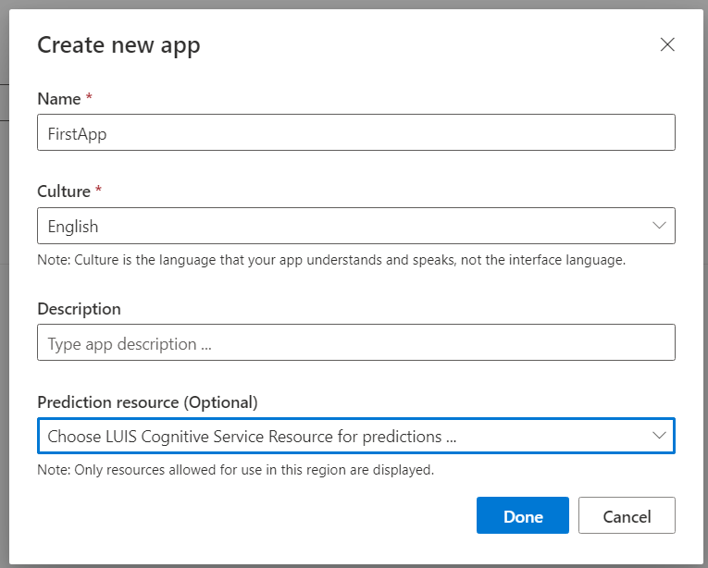

1. New LUIS App created, and it will redirect below screen

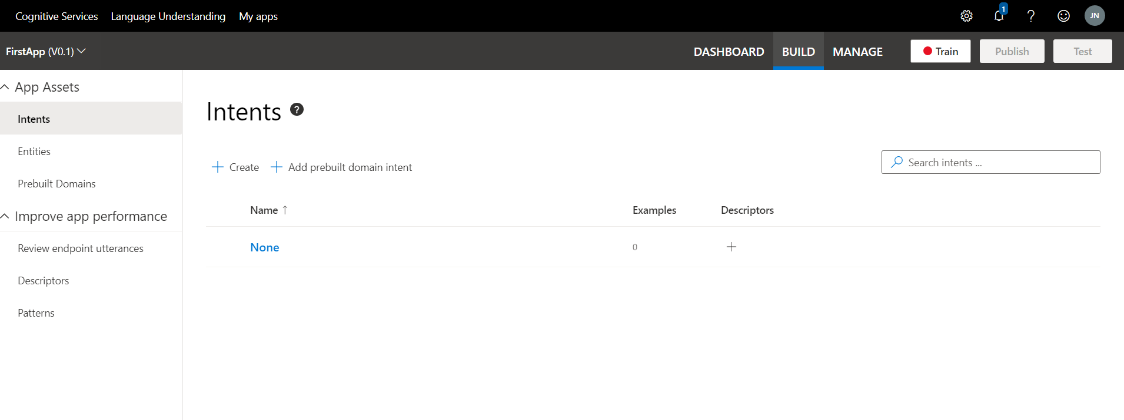

1. Add a new Intent
   1. Create Calendar entry
   2. Add Example Utterance – Hey, want to meet for lunch from 2 to 3

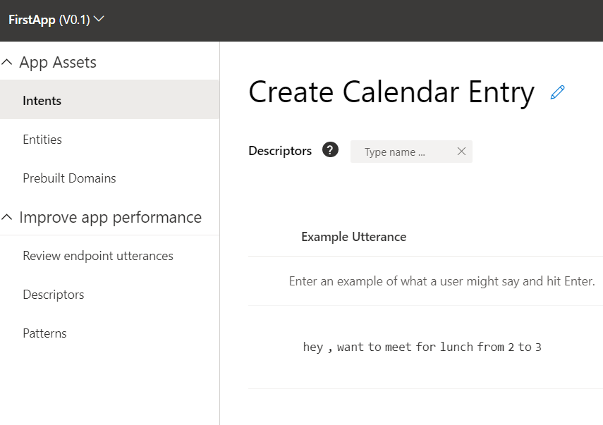

1. Add Entities
   1. Location
   2. State Time
   3. End Time

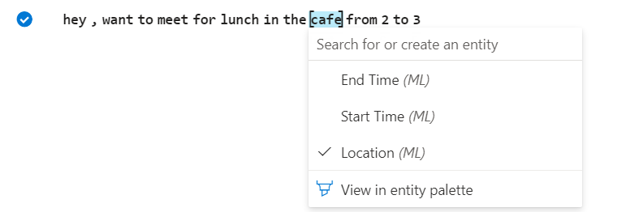

1. Similarly, you can create multiple intents and entities. You are now ready to train your app.
2. The Train the App
3. See the result in notification

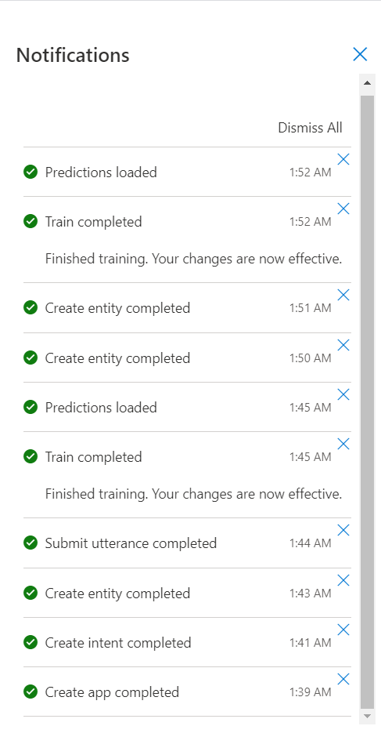

1. Repeat this for several utterances until your app starts to make the right predictions. You're now ready to use your app in Flow.
2. Publish the App

**Step 3: Create an Automated flow**

1. Trigger ‘When a new channel message is added’ MS Teams

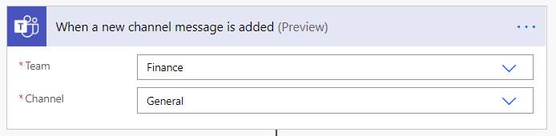

1. Select the Teams and Channel Name
2. Add an action LUIS 🡪 Get prediction
3. Create the connection
   1. Connection Name : <give Name for the connection>
   2. API Key from LUIS App API
   3. Perdition endpoint from LUIS App
4. Under azure resources

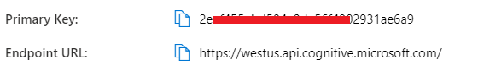

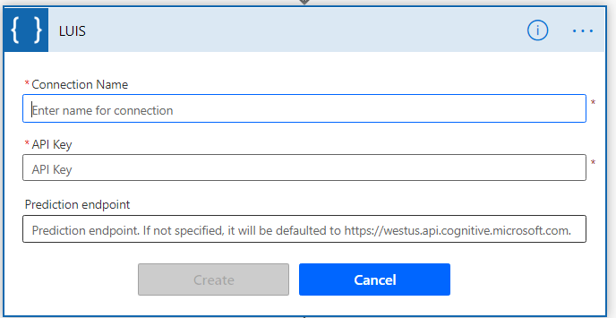

1. Then select the APP ID, add Utterance Text and select Desired Intent

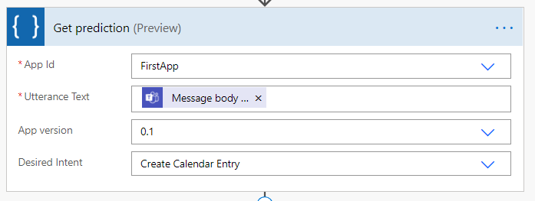

1. Add a condition

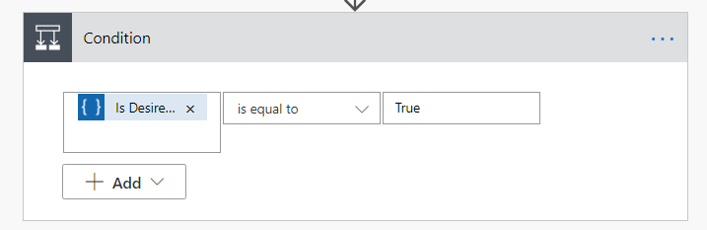

1. Is Desired Intent ‘is equal to’ True
2. Get entities and create an event in google calendar
3. When a new message is posted on MS Teams Channel, detect intent of the message using LUIS Get prediction action.
4. To specify the expected intent, pick a pre-defined value from the Desired Intent dropdown.
5. Add a condition to check if the desired intent is found. In this case, output Is Desired Intent equals True if ‘Create Calendar Entry’ is detected.
6. Use the Get entity by type action to fetch ‘Start Time’ from the query string.
7. Use the second Get entity by type action to fetch ‘End Time’ from the query string
8. Using the entity values from Start Time and End Time, create a new event in Google Calendar.

